1. An object of mass 500g moves down a slide from vertical height of 3.0m as shown in Fig 11.3. Object A was released with an initial speed of 5.0m/s and its speed at its lowest point L was 8.0m/s. 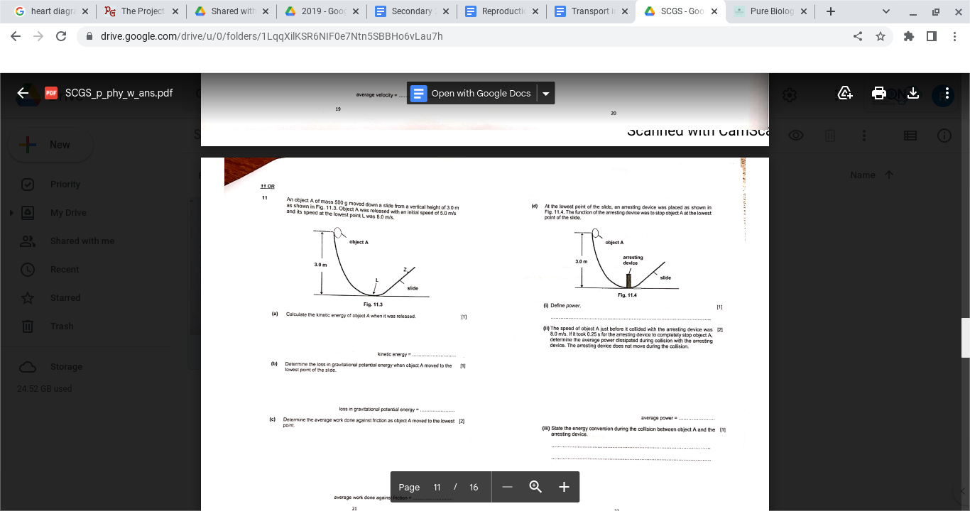
2. Calculate the kinetic energy of object A when it was released. [1]

1. Determine the speed of the ball when the ball reaches Z, if the height at point Z is 1.5m [2]
2. Determine the energy change of object A from the initial position to Point Z.